The Cost of Controlling the Sky

Rain, rain go to Spain, fair weather come again.
In the 17th century when John Howell wrote that rhyme which later became the well-known children’s nursery rhyme rain, rain go away come again another day. I bet he never imagined a world where humans would have the ability to interfere with Mother Nature by directly influencing and modifying the weather to get desired results, fast forward to the present day and that is exactly what governments and private companies are doing.
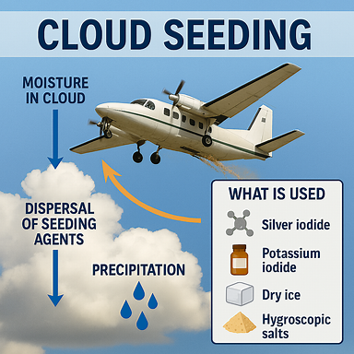
Cloud seeding is a process that puts substances like Silver Iodide into the earth’s atmosphere which affects clouds by altering the amount and type of precipitation, this is typically done by airplane, generators or drones.

Weather Modification is not an entirely new practice during the Vietnam war between 1967 -1972, weather modification was weaponised to cause unnatural floods in Vietnam, which resulted in Loss of life and property, damaged crops, infrastructure, and local ecosystems, disrupted rivers and soil stability, sometimes creating long-term ecological imbalances., Some chemicals used, like silver iodide, can persist in the environment. Although generally considered low-toxicity, repeated or large-scale use raises questions about soil, water, and wildlife impacts.. Communities affected by sudden heavy rainfall often faced food shortages because crops were destroyed.
This sparked ethical and legal debates about the human cost of using weather as a weapon. In 1977 a law was passed by the EMNOD Convention making it illegal to modify the weather for military/ hostile purposes, establishing a precedent in international environmental law.
Today it is used in different countries to help to stop heat waves and wildfires. Insurance companies use it to help mitigate damage to properties caused by hail stones but like most things cloud seeding may come at a cost, which in this case could be the public’s health and the environment.
In my opinion, nature is often at its best when left alone, allowing ecosystems to find their own balance and rhythms. interfering with the weather has real consequences for people and nature. What do you think—should we try to control the weather or let nature take its course?
If this week’s blog interested you, why not do some further research.

